**CHARTING THE COURSE OF INNOVATION :**

**A START UP ANALYSIS**

**SUBMITTED BY**

**TEAM LEADER :** LENISHA L

**TEAM MEMBER :** MAJALLA HARISHNY A

**TEAM MEMBER :** JENI STEPHEN J

**TEAM MEMBER :** SINDHUS NIGITHA D

**INTRODUCTION**

**1.1 Overview**

You must have heard about the theory ‘survival of the fittest’; you must also have heard a statement: “A smooth sea never makes good sailors”.Both the ‘survival of the fittest’ theory and the statement above fit really well with the world of startups. And the world of startups is a violent one. there is a huge paradigm shift. And that shift has challenged the overall functionality of startups.Challenges are everywhere. And businesses – in general and startups in particular – are no exception to myriad of challenges that we face today.I am not going to go into details about what is a startup and how it works; we all know that. In this particular blog post, I am going to elaborate about some of the biggest challenges being faced by small business startups.

**1.2 Purpose**

The purpose of a startup is multi-faceted, depending on the individual or team behind the venture. Generally, though, the purpose of a startup is to create something new and innovative. A startup is often the first step in launching a business venture, and is the beginning of an entrepreneurial journey. Startups often start small and grow as they attract funding or customers. From fashion startups to food startups, there is an endless array of potential business ventures that can be launched under the umbrella of a startup.

**2. PROBLEM DEFINITION AND DESIGN THINKING**

**2.1 EMPATHY MAP**

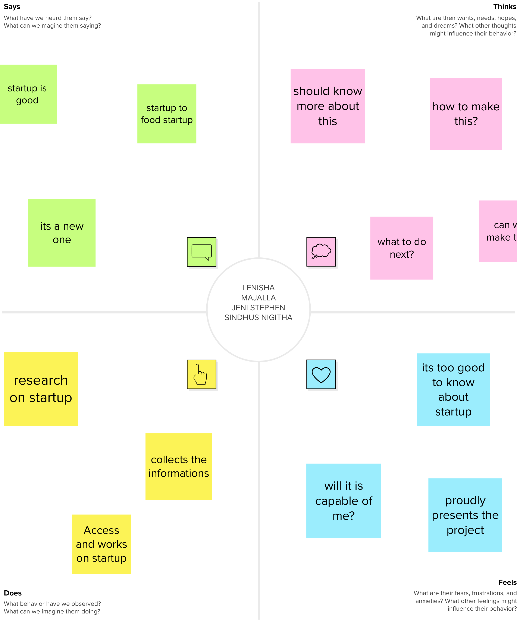

**2.2 IDEATION & BRAINSTORMING MAP**

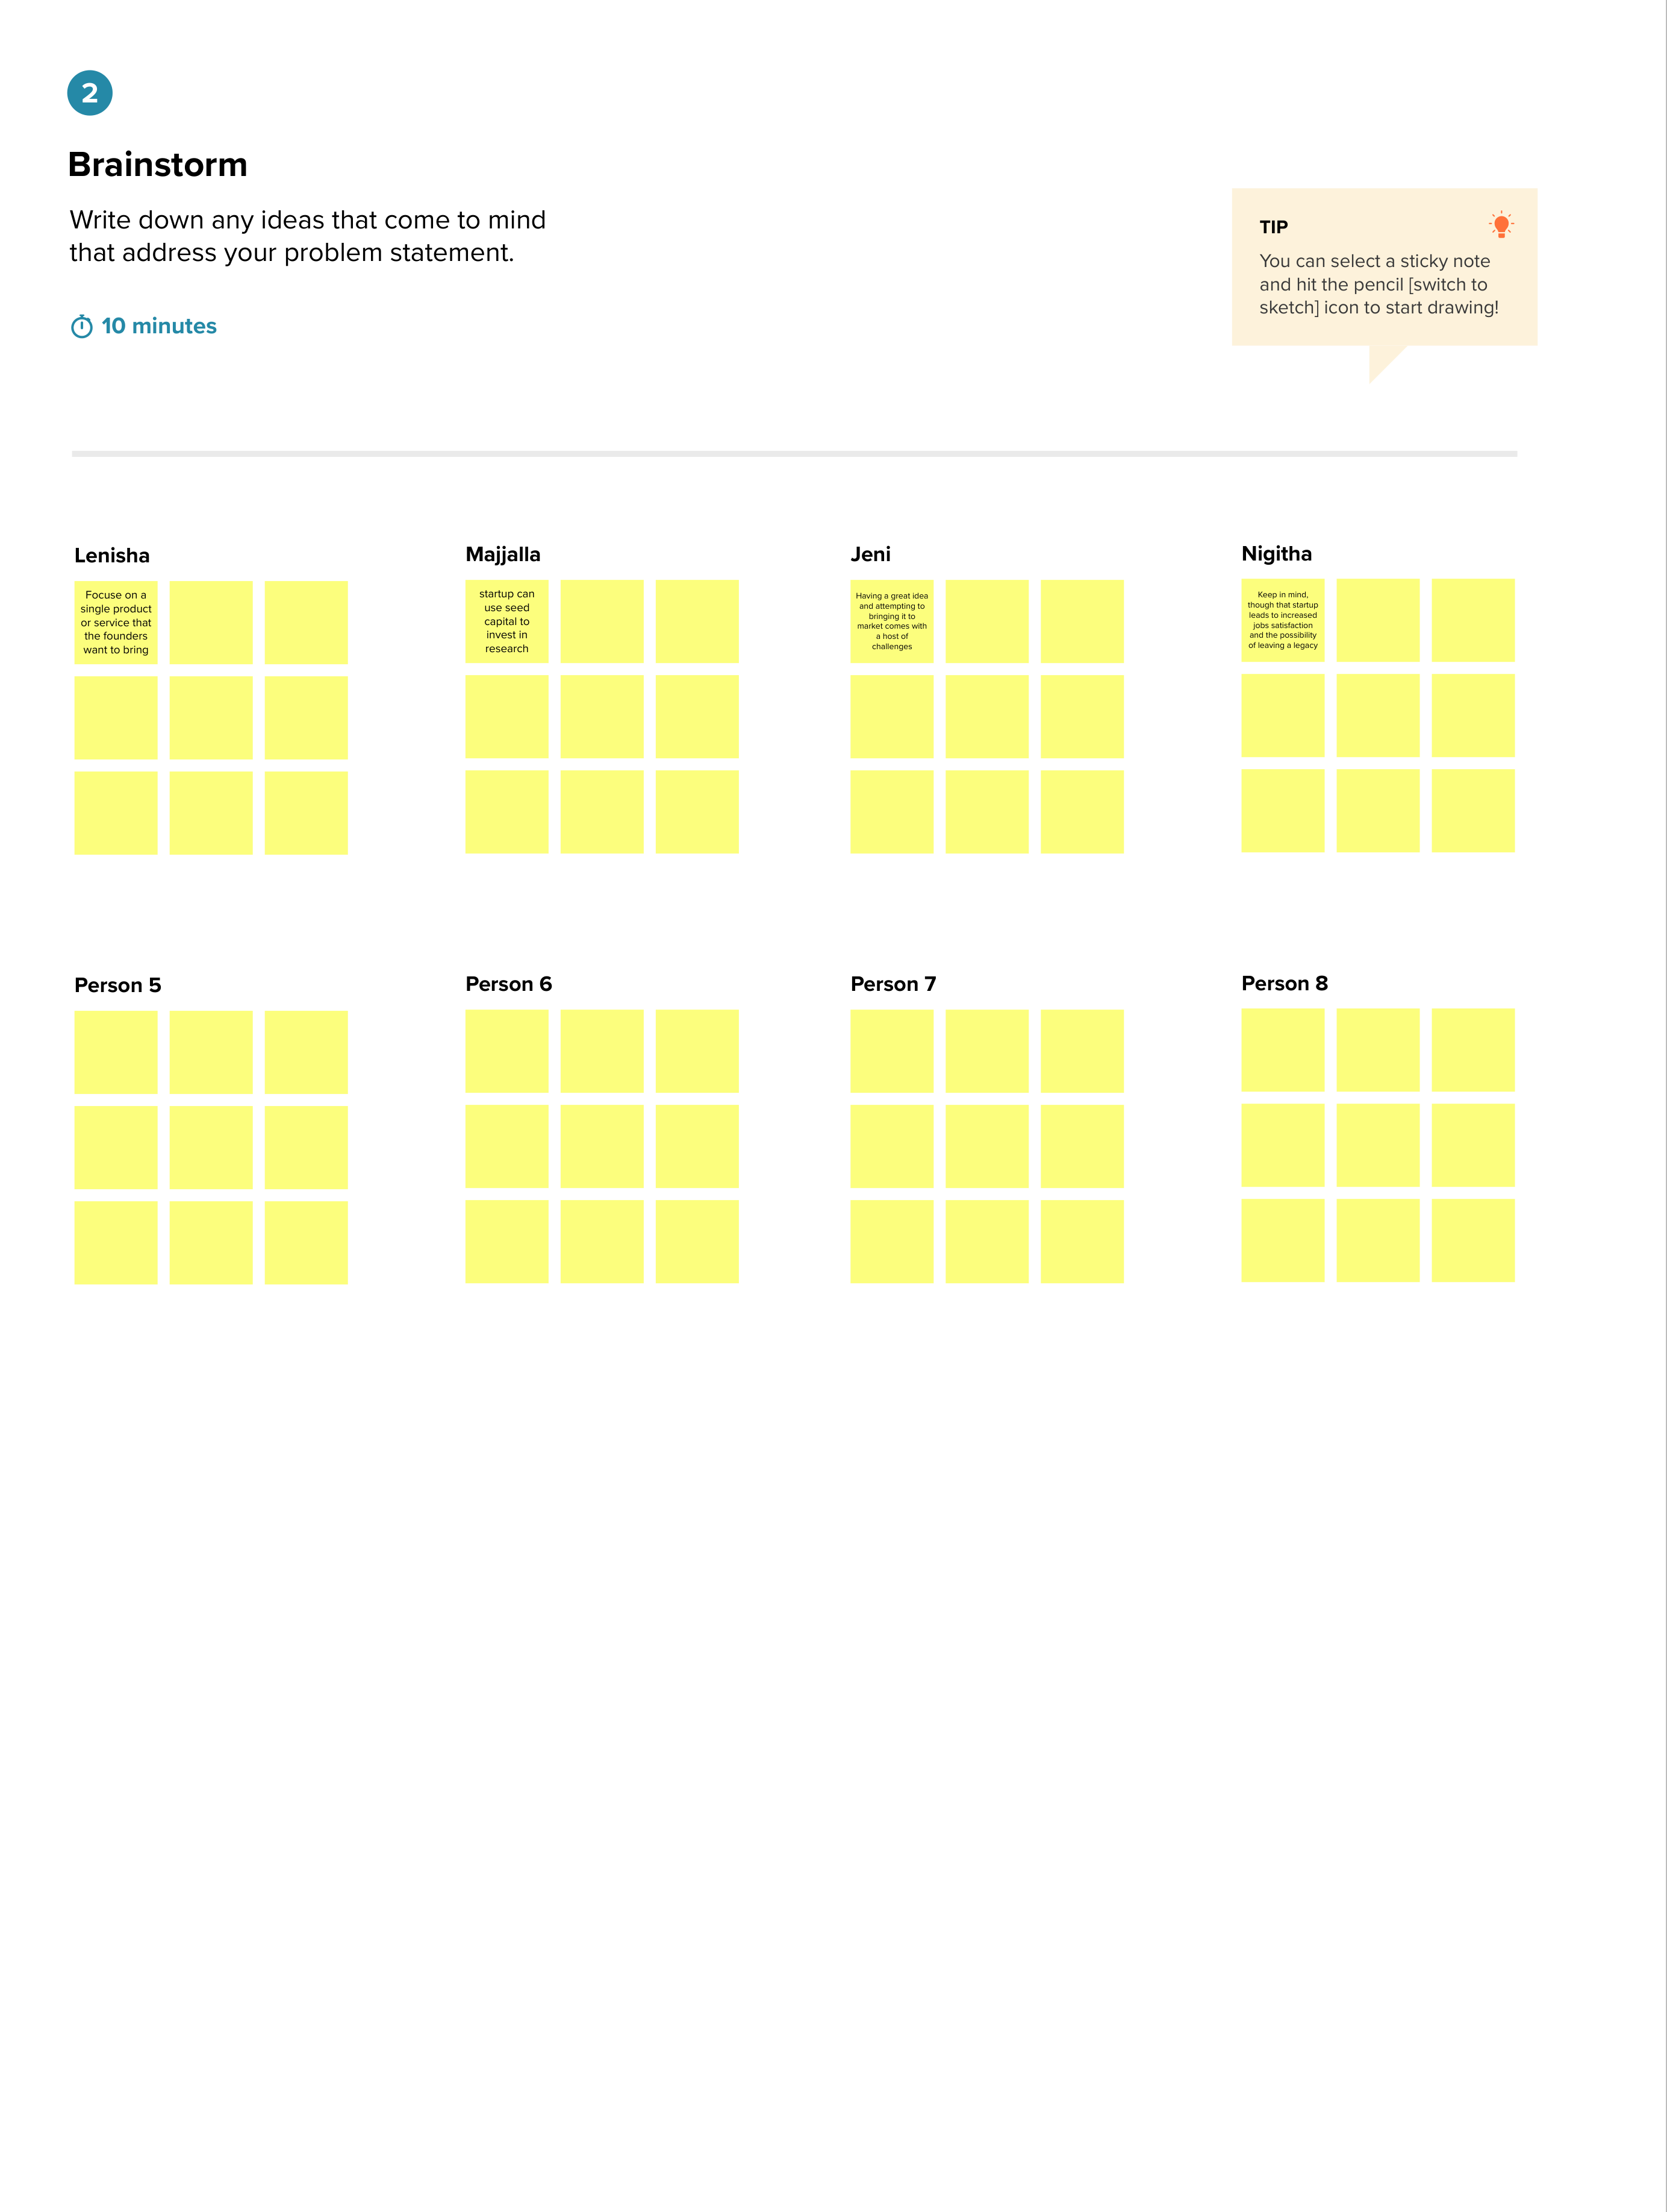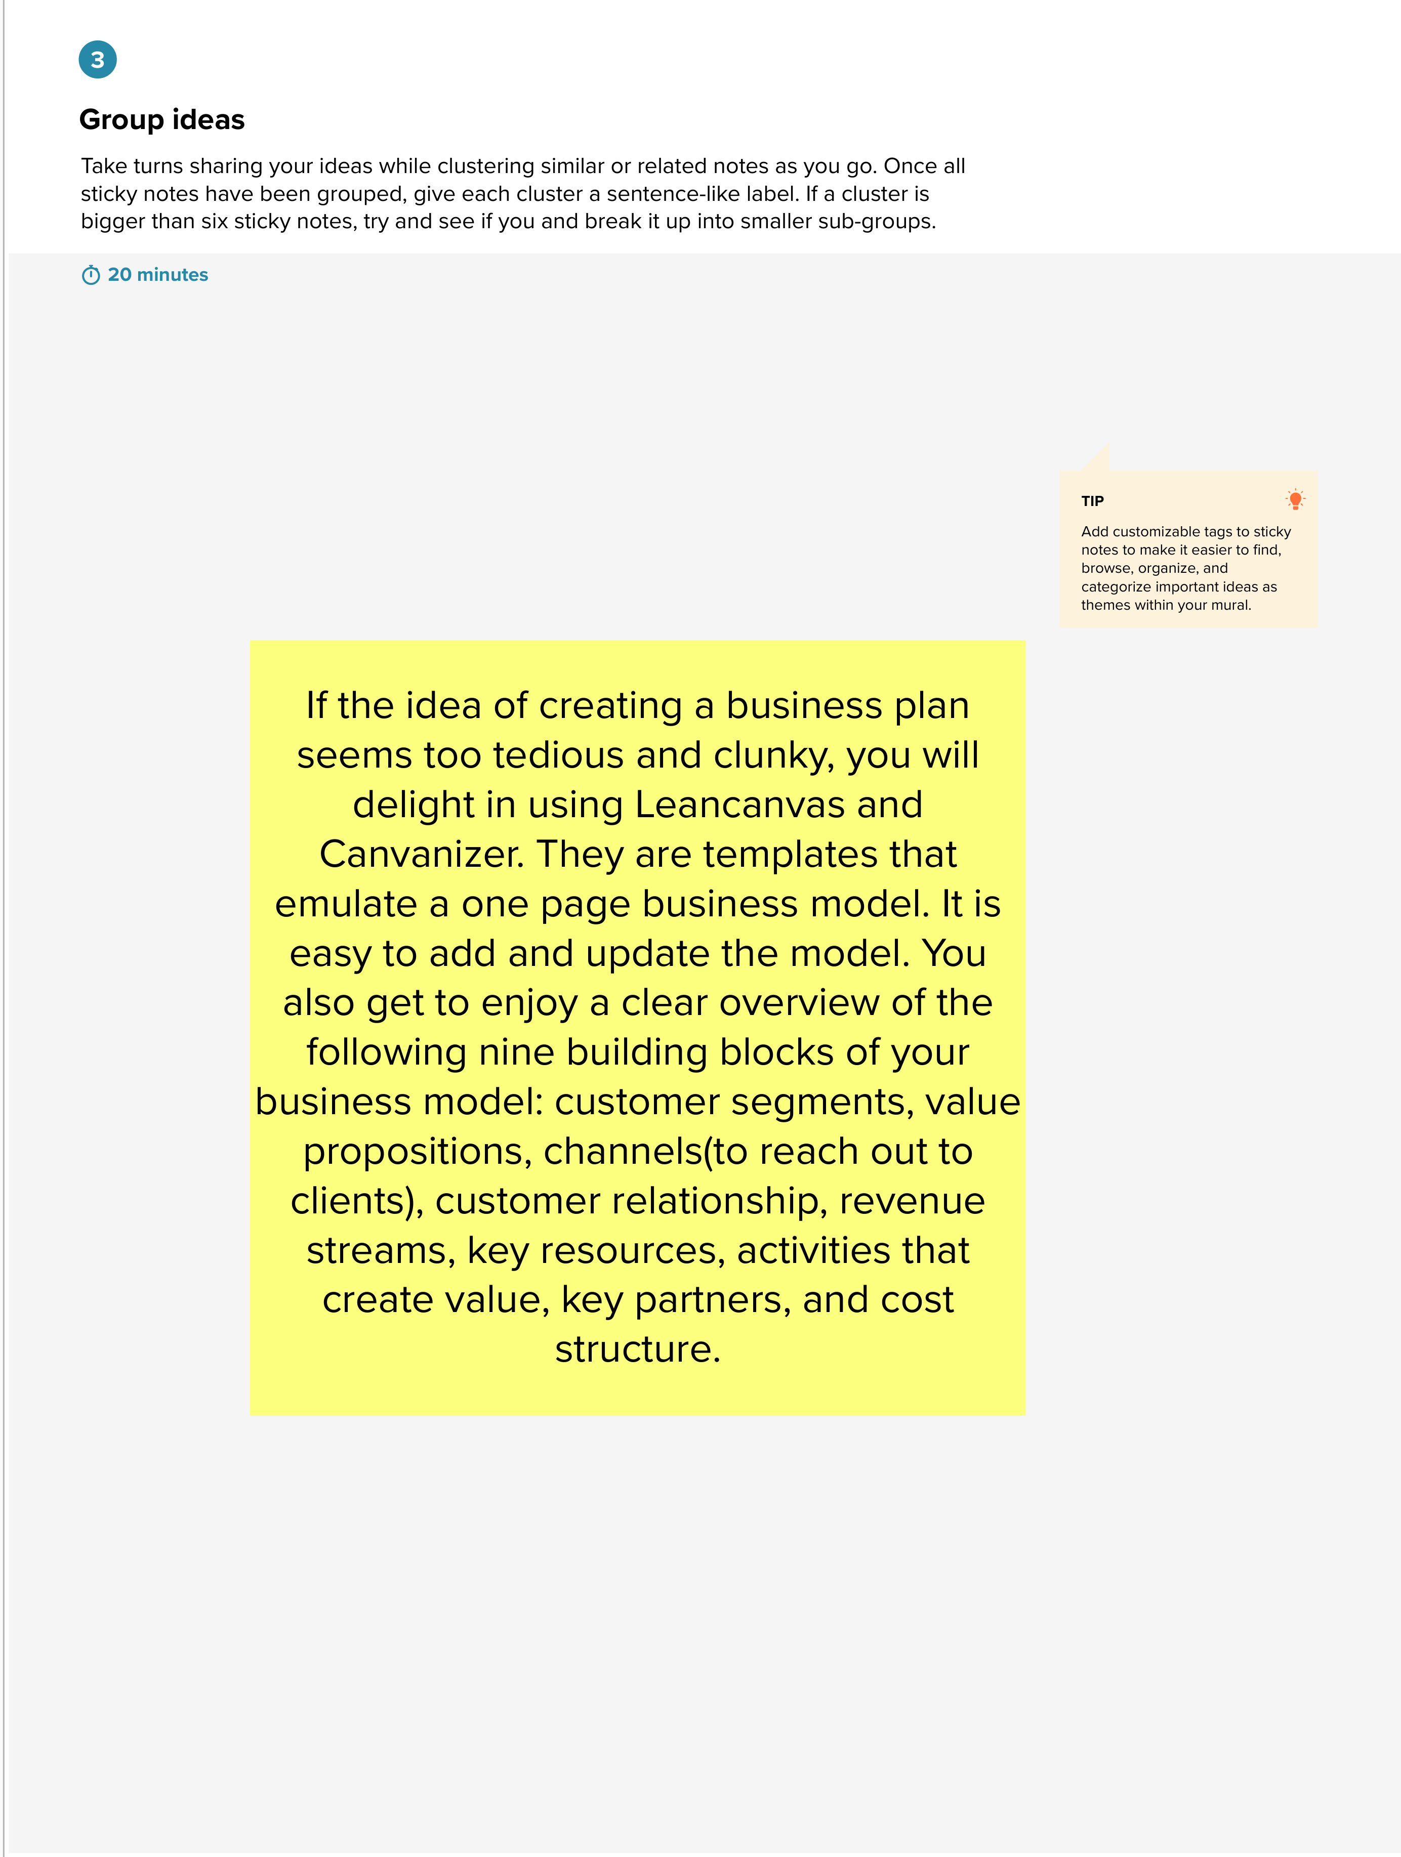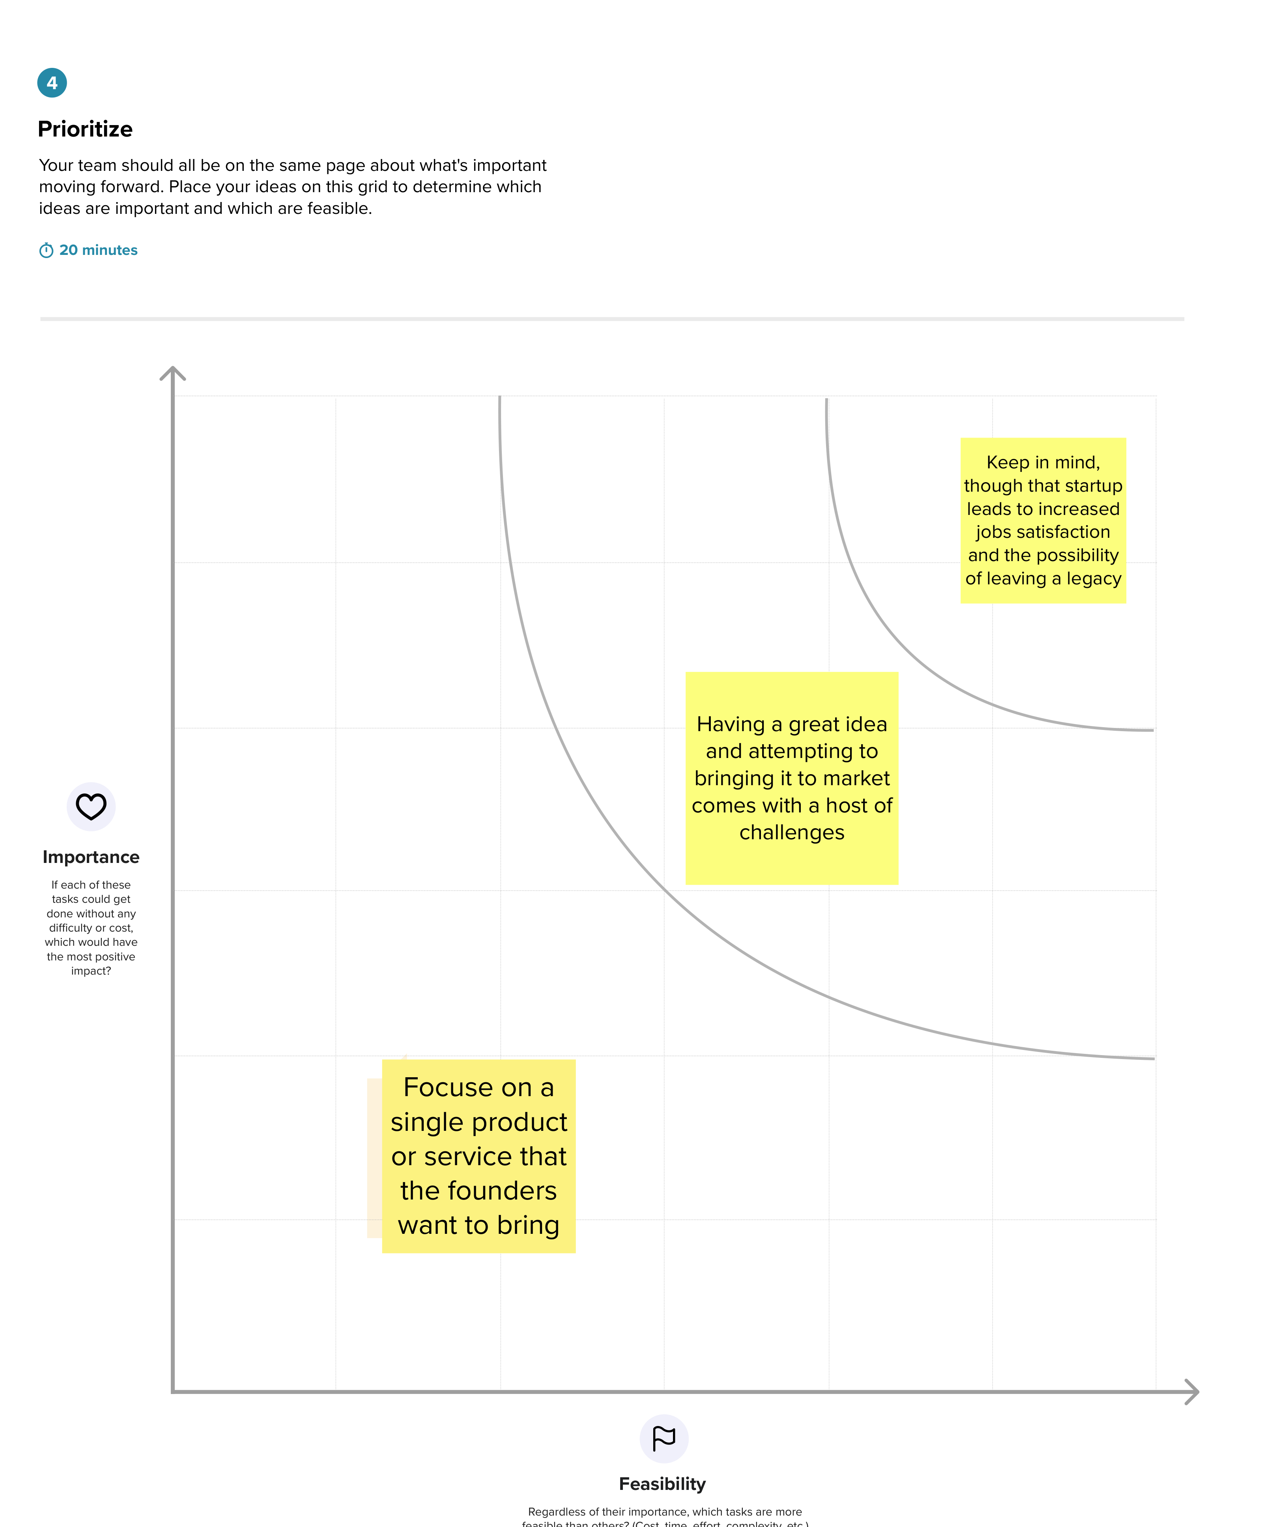

**3. RESULT**

**3.1**

**DASHBOARD**

**A dashboard is a collection of several views, letting you compare a variety of data simultaneously.**

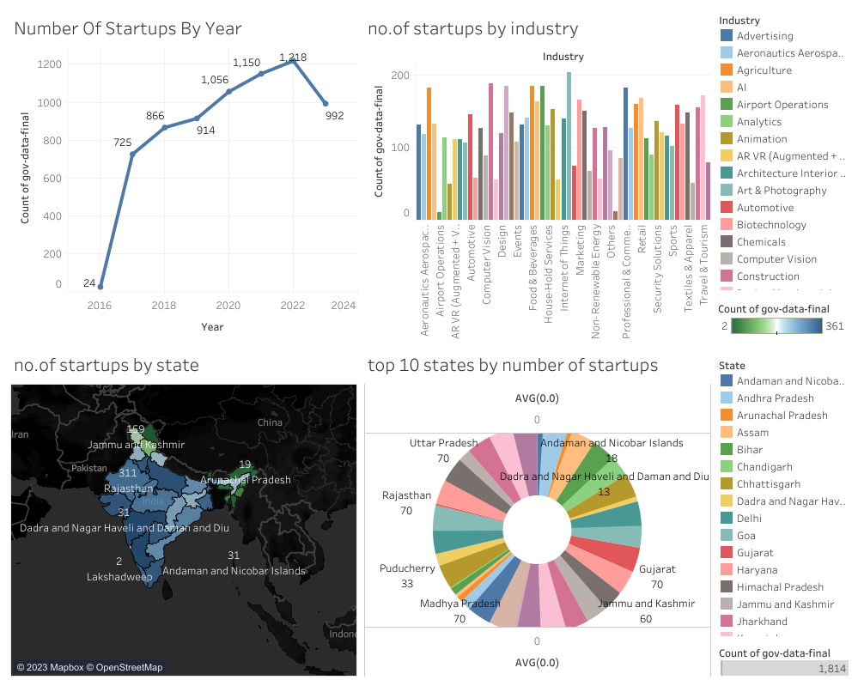

**3.2 STORY**

A story is a sheet, so the methods you use to create, name, and manage worksheets and dashboards also apply to stories. At the same time, a story is also a collection of sheets, arranged in a sequence. Each individual sheet in a story is called a story point.

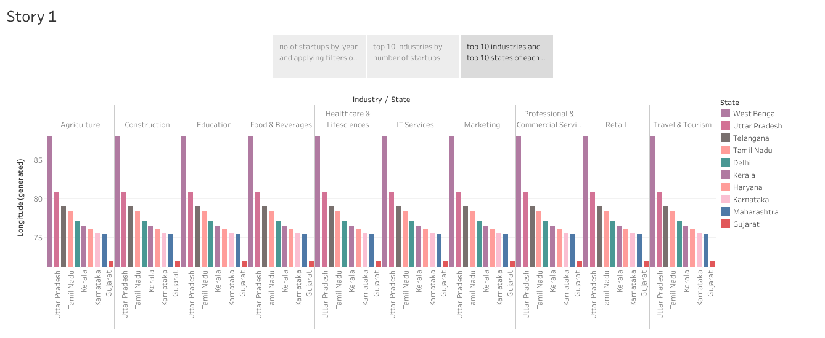

**4. ADVANTAGES AND DISADVANTAGES**

**Advantages:**

1. Agility::

Startups are smaller and less structured. They are also innovative and keep improving their business models, processes, and portfolio. These allow them to adapt to disruptive technologies and changes in market conditions. Established competitors face vested interests, a historic path, and a strong team culture. This makes them resistant to change

2. Efficiency (Lean and Mean)

Startups have lower administrative overheads and offer their services in an efficient, cost-effective and competitive manner. They are likely to be aware of their limitations and tend to focus on their core strengths. Startups easily recognize the benefits of partnering with other like-minded organizations to present the customer with an equal or superior value proposition.

3. Team Culture

Employees of large corporations are attracted and retained by prestige and big salaries. They easily lose sight of the company’s vision, mission and values and the success of its customers. Startup employees on the other hand form a close-knit community that shares passion, beliefs and values. They must work together for the good of the company, its customers and the world at large.

4. Personalization

Startups deliver their products and services with a personal touch and create a unique a personal experience for their customer. Due to their agility they can adapt their offerings to unique customer needs and preferences. Startups typically take more time to understand and satisfy your business requirements, since every customer is a big deal to them.

5. Versatility

It’s common that employees of startups multi-task and the person making the sale could become the relationship manager during the implementation phase. This builds trust with the client and offers a guarantee for successful delivery and implementation. The versatility of startup employees is reinforced by a team culture that encourages learning and innovation.

**Disadvantage:**

1. Risk

Most startups fail within their first year of operations for various reasons, so the risk of failure is high. Working under such circumstances can cause startups to be overly cautious in seizing market opportunities or overly optimistic in estimating the potential market for their products and services. It also means that startups find it difficult to attract experienced and competent staff.

2. Compensation

Long working hours are the norm for startups, since companies are built by blood, sweat and tears. The rewards might not be forthcoming, and it could take several years before the company starts making revenue and becomes profitable. Working without pay or for low compensation is demotivating, and some startups fail to persist and simply give up.

3. Market Access

Many businesses prefer to work with businesses they know and have worked with, and this puts startups at a serious disadvantage. Established businesses also spend less money and effort on retaining existing customers than startups spend on acquiring new customers. Without a customer base, startups notably struggle to understand the evolving market needs and preferences.

4. Team Composition

Some startups are born out of desperation, since the founder could not find or hold on to a job. Most of such founders become solopreneurs who struggle to build a team that the business needs to succeed. A startup venture requires founders / co-directors who complement each other in personality and competencies, but disagreements easily creep in when the going gets tough.

**5. APPLICATIONS**

The examples of implementing Big Data for each startup company are different. Therefore, the solutions provided by Big Data can also be different in terms of the type of business, consumers and the area where the business is established. Many startups whose focus is on online transportation are using this Big Data technology. With Big Data startups are easy to get data from consumers. With this data, it can be used to improve services and also make innovations in services.

The application of Big Data at startups makes these startups able to know the activities and know the trends that are mostly carried out by customers. With this they will be able to provide the right recommendations for their customers such as free shipping, vouchers and discounted prices and so on.

The way Big Data analyzes customer activity is after making a transaction. Looking at the transaction history carried out by this technology, it will provide recommendations that startups can do where this is still related to the transaction history. They do this innovation to satisfy customers and can only be done if the company implements Big Data in their company.

Make your business more advanced and grow by implementing Big Data in your company. You can use Big Data solutions from SOLTIUS to solve problems in your business and make them grow according to your expectations.

**6. CONCLUSIONS**

In recent years, startups have been receiving increased attention in many parts of the world. In India, the number of startups has increased fast and more support has become available in all dimensions. It is due to vast commercial potential for startups, India is often described as “the poster child of emerging markets”.

Today Startups are being widely recognised as important engines for growth and jobs generation. Through innovation and scalable technology, startups can generate impactful solutions, and thereby act as vehicles for socio-economic development and transformation.

However, still there are many challenges that act as a hindrance in realising the true potential of startups in India.

**7. FUTURE SCOPE**

In a recent development, the government created a program like “Make in India” to promote prospects for employment. There are a few key elements to consider while discussing scope in India that may help in effectively establishing a business as well as its ongoing investigations. Youth oriented: India has a large and desperately unemployed young labor force. This country has a youth-oriented demography. They possess education and are simple to instruct. These resources maybe utilized for personal benefit, creating occupations that have a positive influence on society while simultaneously producing wealth for the individual.

Large Population: The economy works on the principles of supply and demand. India already has a sizable market with a wide range of demand that has to be satisfied due to its large population, which is great to start-up a business for every businessman.